Questions

Question 1
FL Review - start at 13:51
Q1
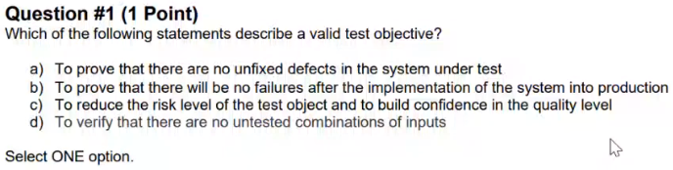
Q1 - Answer
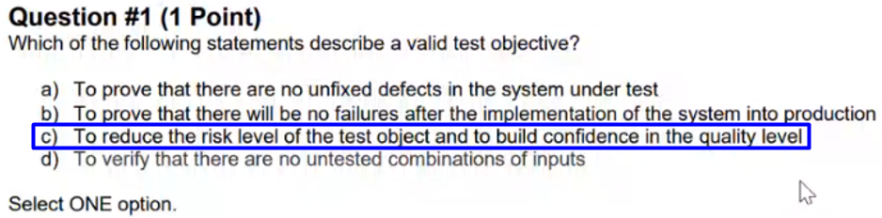

Question 2
FL Review - start at 18:56
Q2
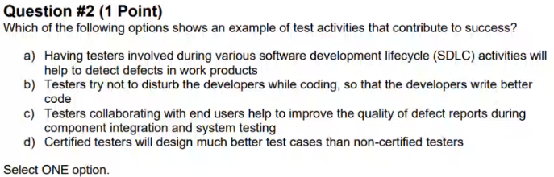
Q2 - Answer
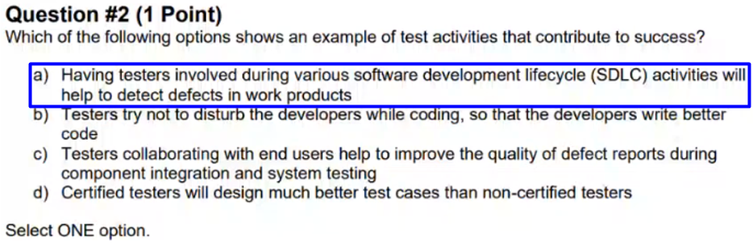

Question 3
FL Review - start at 21:42
Q3
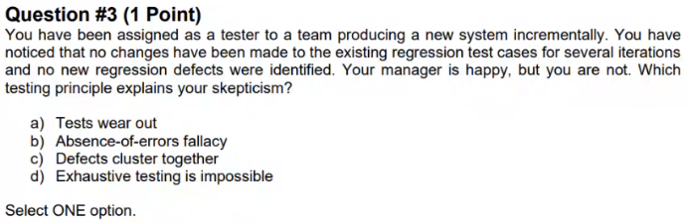
Q3 - Answer
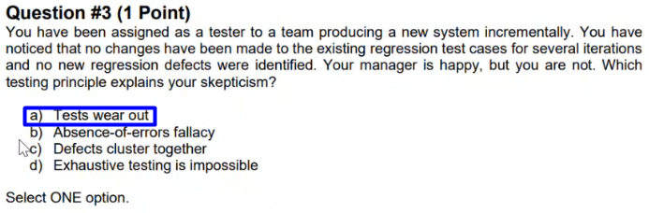

Question 4
FL Review - start at 24:30
Q4
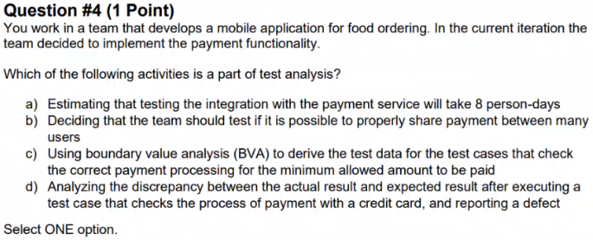
Q4 - Answer
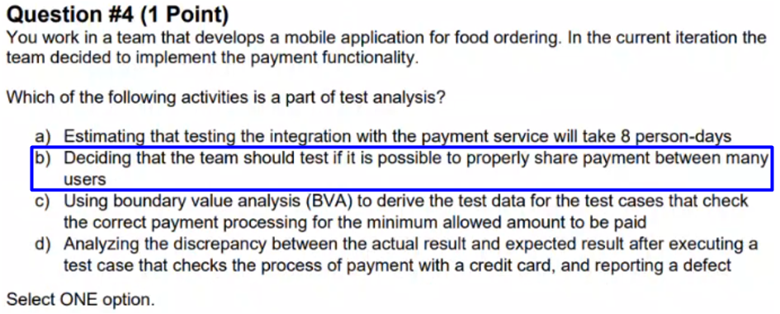

Question 5
FL Review - start at 28:34
Q5
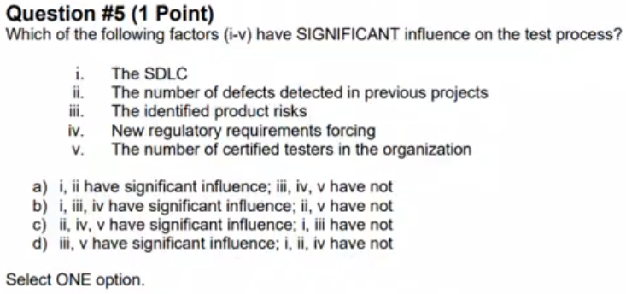
Q5 - Answer
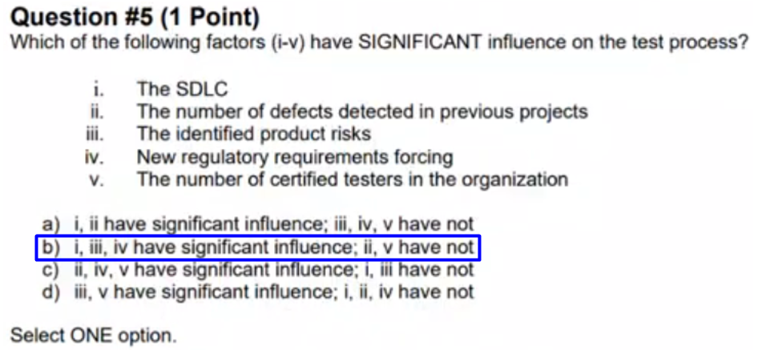

Question 6
FL Review - start at 32:42
Q6
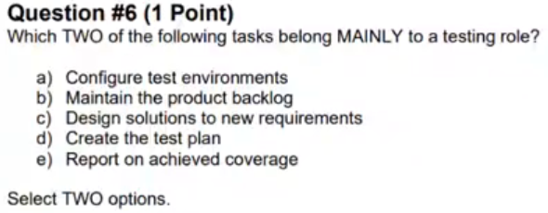
Q6 - Answer
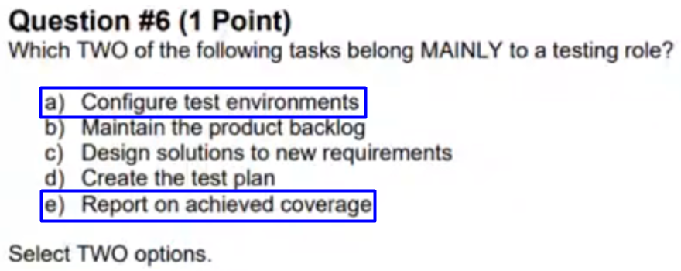

Question 7
FL Review - start at 35:43
Q7
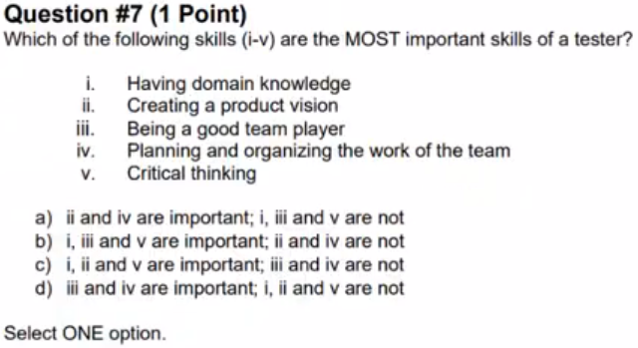

Q7 - Answer
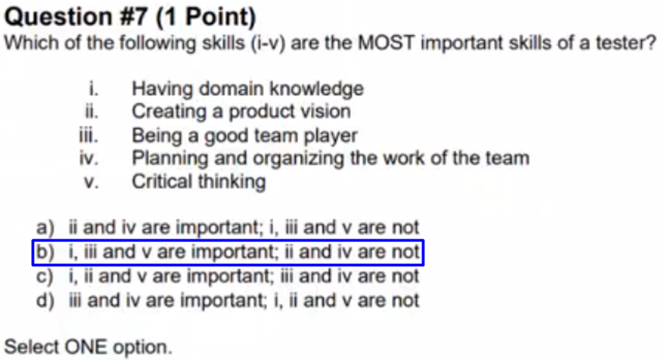

Question 8
FL Review - start at 37:34
Q8
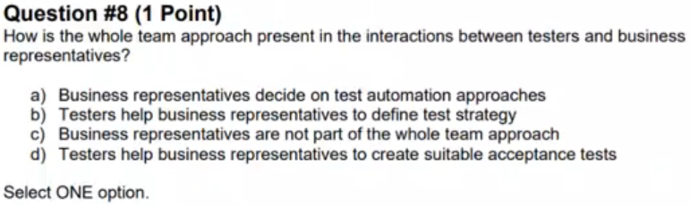

Q8 - Answer
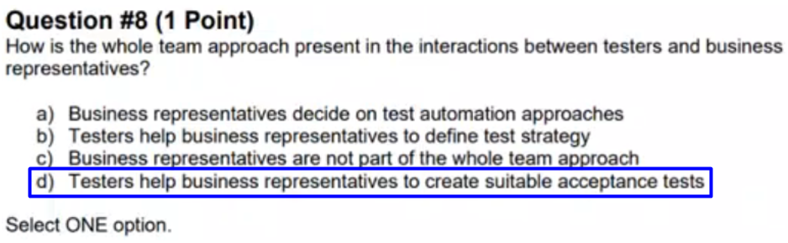

Question 9
FL Review - start at 39:36
Q9
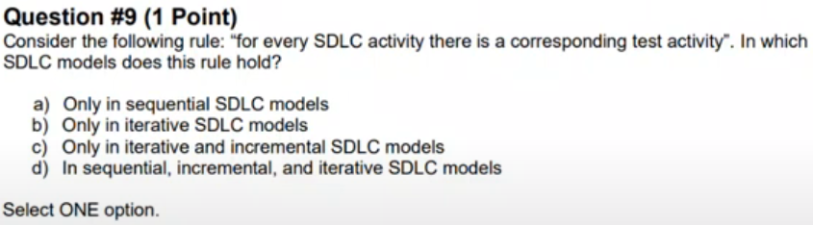
Q9 - Answer
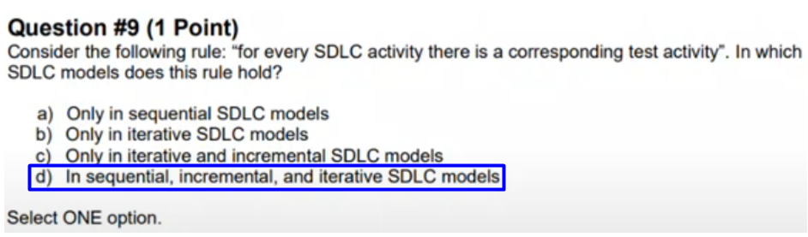

Question 10
FL Review - start at 40:43
Q10
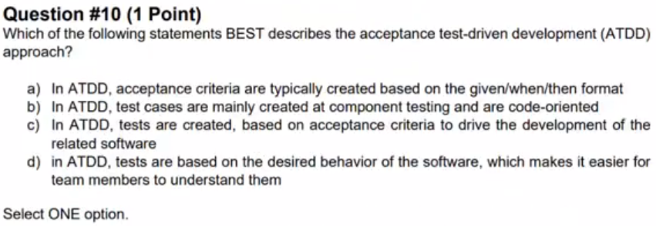
Q10 - Answer
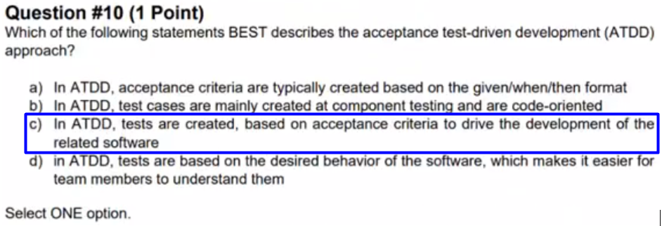

Question 11
FL Review - start at 42:17
Q11
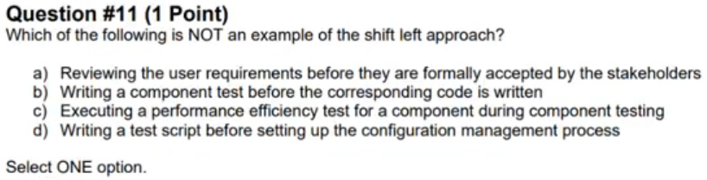
Q11 - Answer
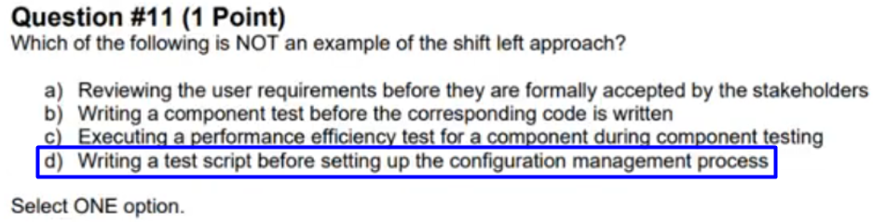

Question 12
FL Review - start at 46:23
Q12
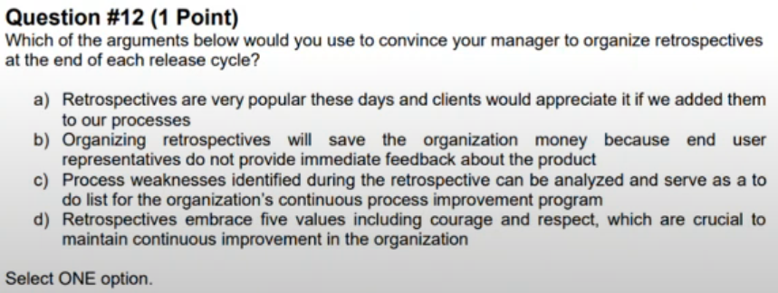
Q12 – Answer
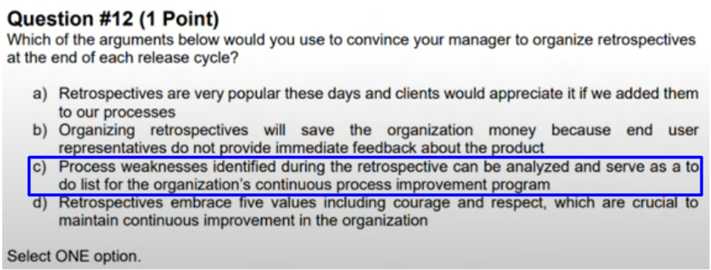

Question 13
FL Review - start at 48:45
Q13
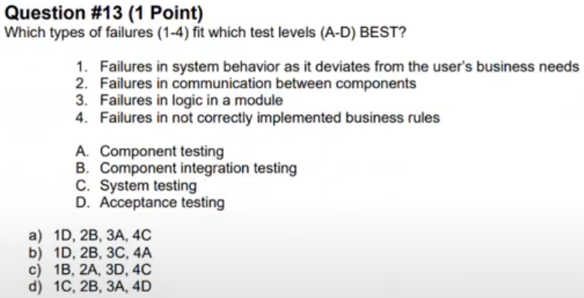
Q13 - Answer
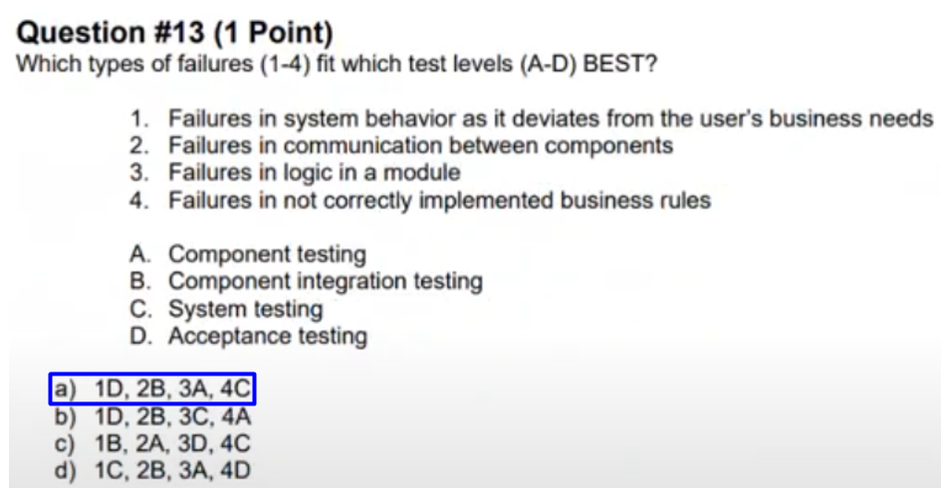

Question 14
FL Review - start at 50:44
Q14
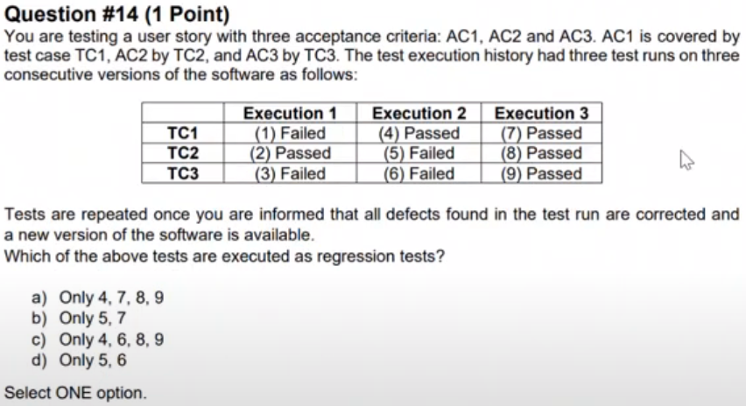

Q14 - Answer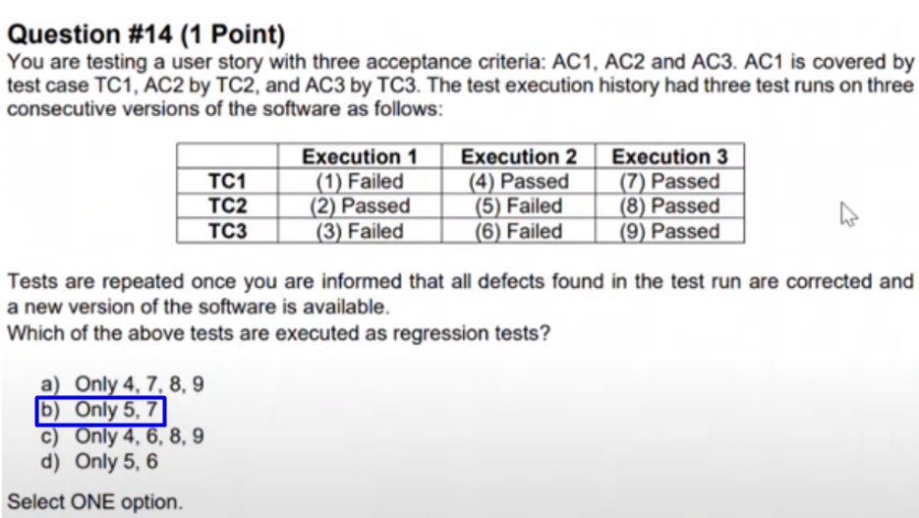

Question 15
FL Review - start at 55:22
Q15
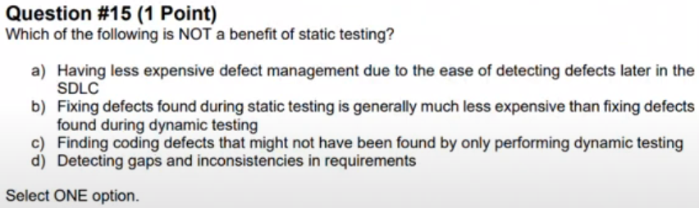
Q15 - Answer
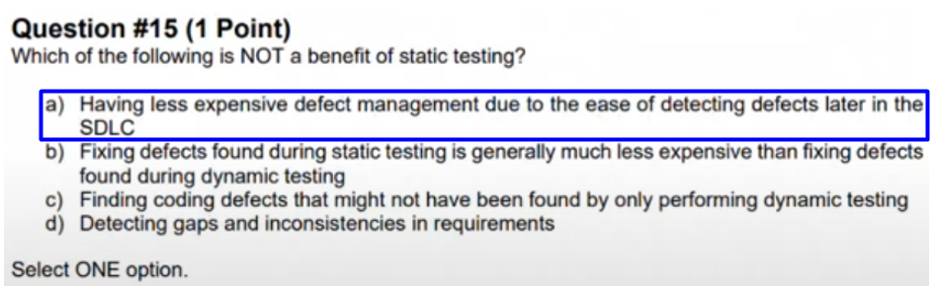

Question 16
FL Review - start at 59:07
Q16
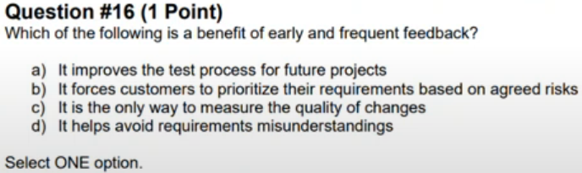
Q16 - Answer
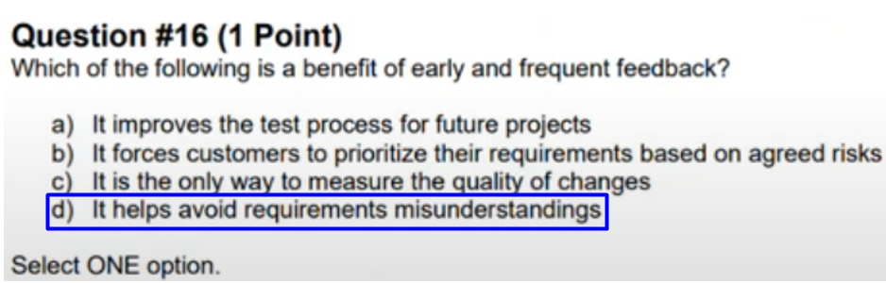

Question 17
FL Review - start at 1:00:37
Q17
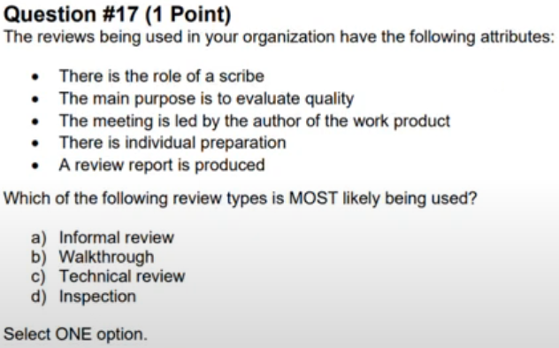
Q17 - Answer
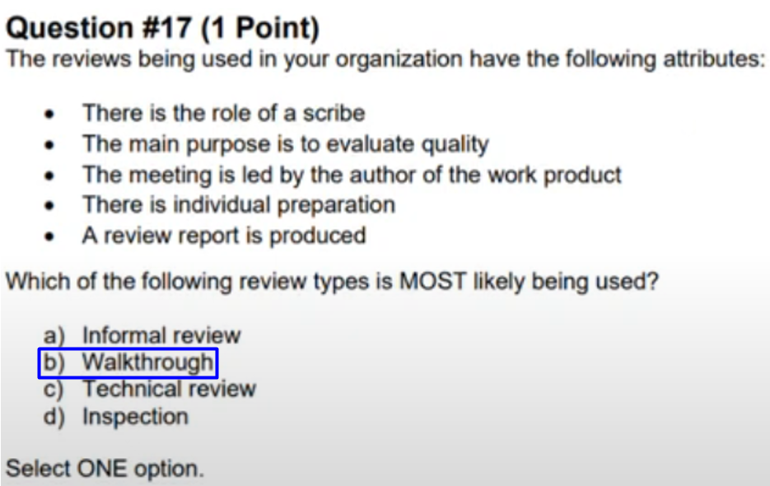

Question 18
FL Review - start at 1:02:07
Q18
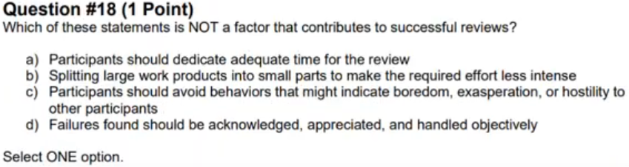

Q18 - Answer
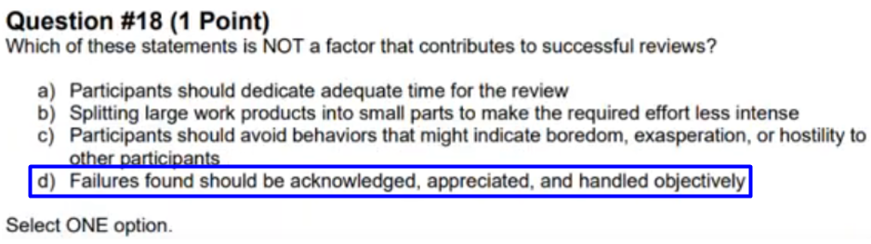

Question 19
FL Review - start at 1:03:55
Q19
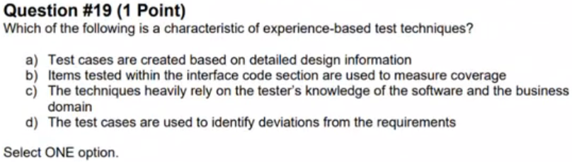
Q19 - Answer
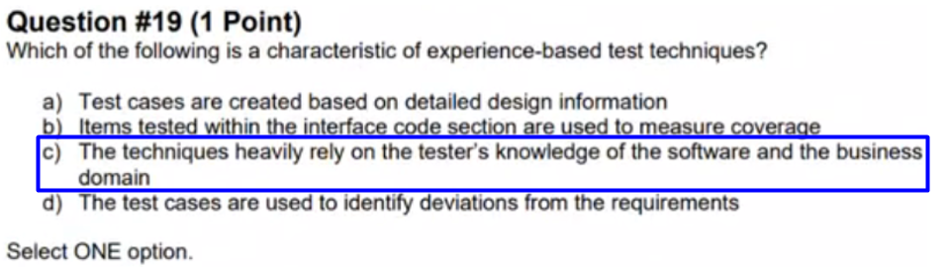

Question 20
FL Review - start at 1:05:20
Q20
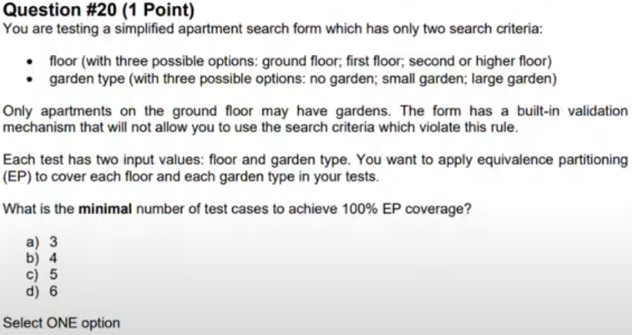
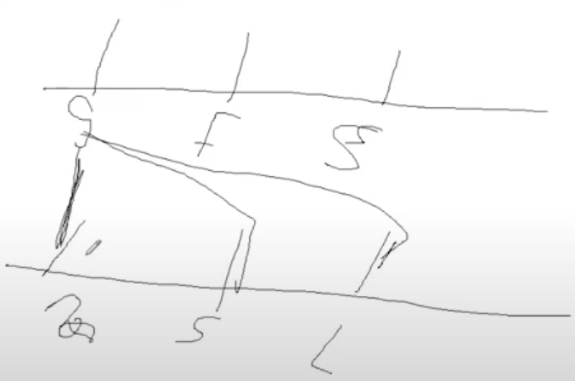
Q20 - Answer
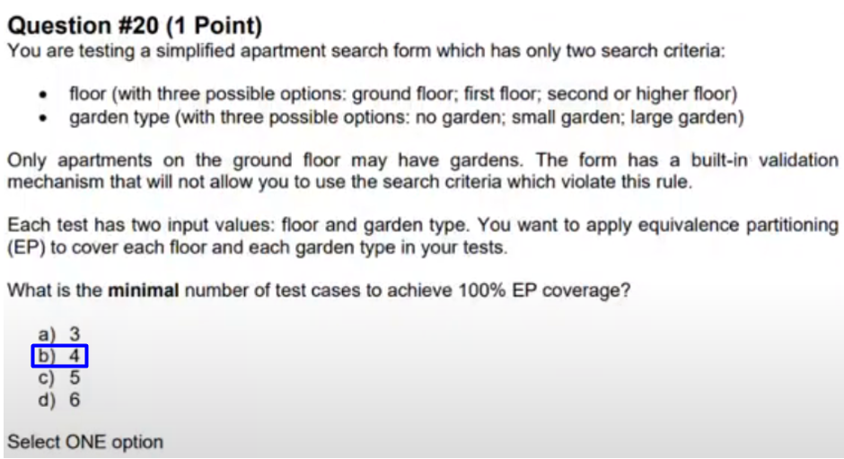

Question 21
FL Review - start at 1:12:52
Q21
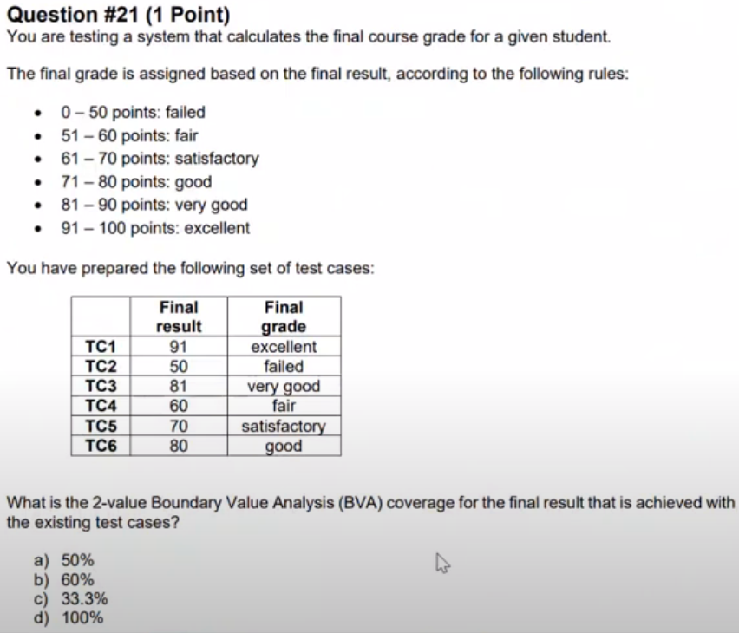
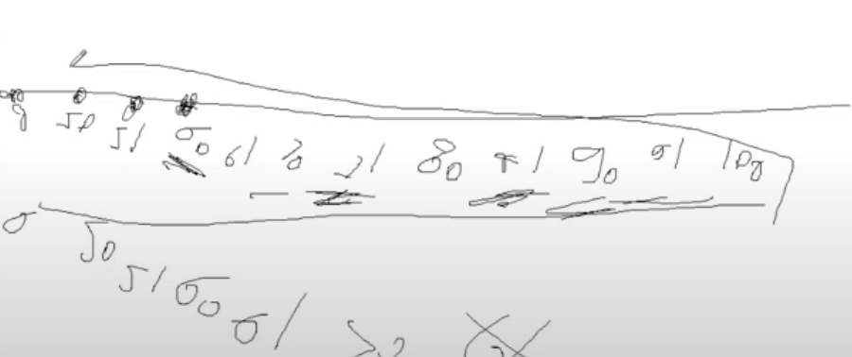
Q21 - Answer
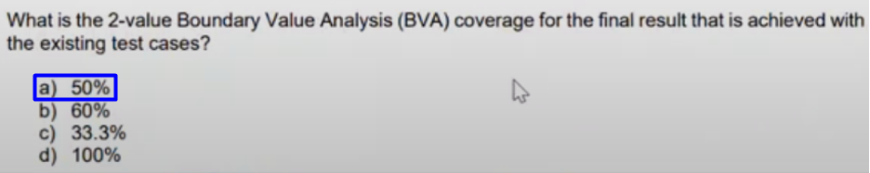

Question 22
FL Review - start at 1:21:54
Q22
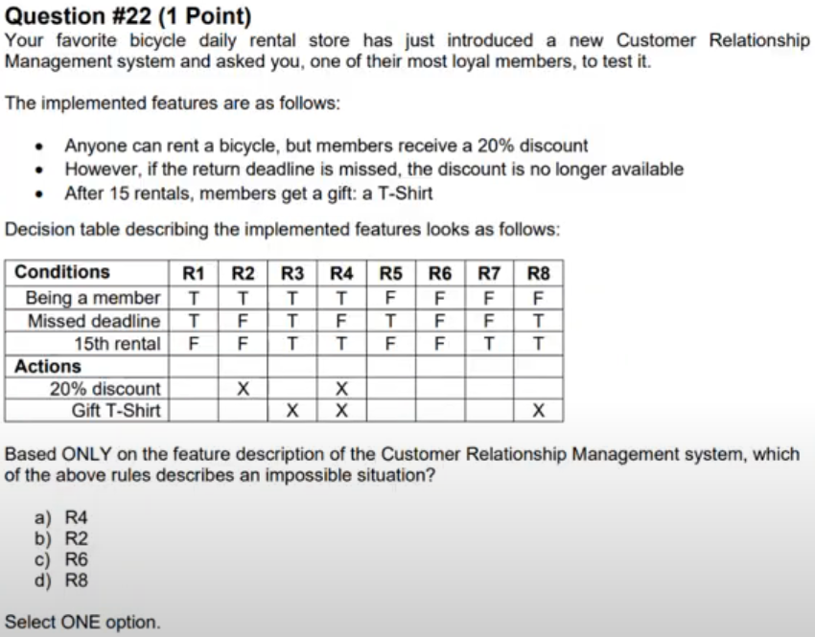
Q22 - Answer
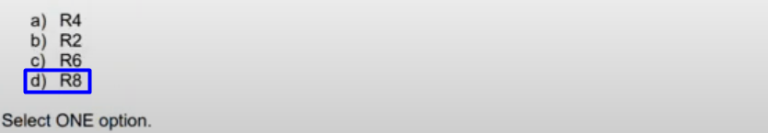

Question 23
FL Review - start at 1:25:24
Q23
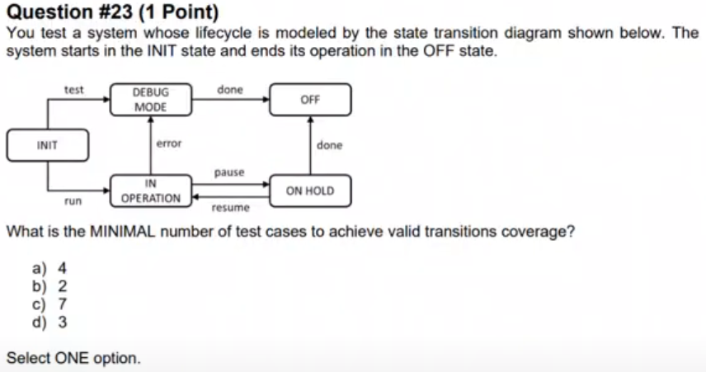

Q23 - Answer
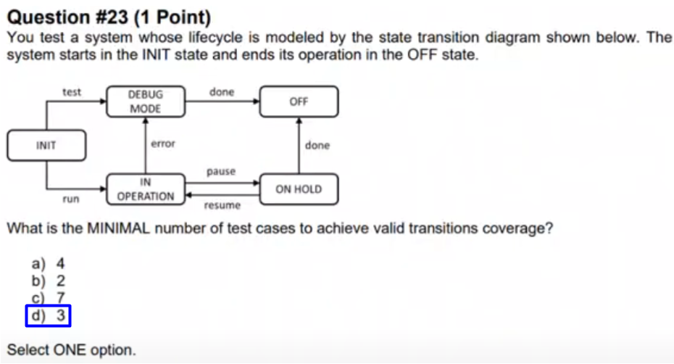

Question 24
FL Review - start at 1:29:39
Q24
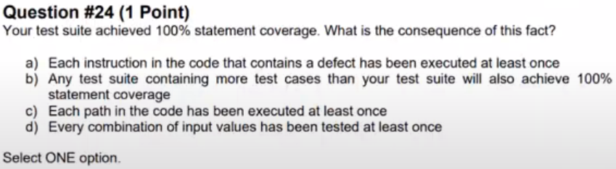

Q24 - Answer
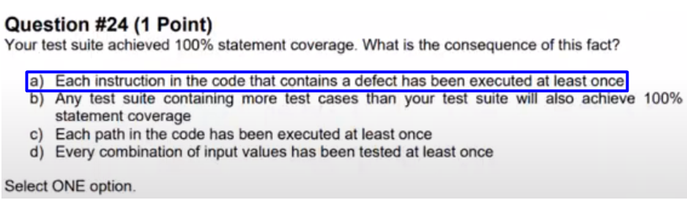

Question 25
FL Review - start at 1:32:18
Q25
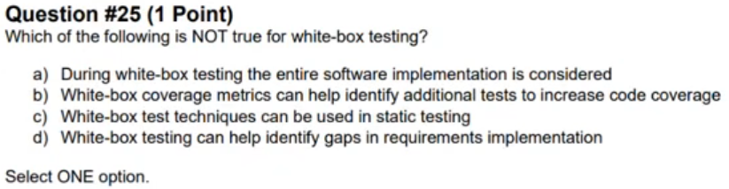
Q25 - Answer
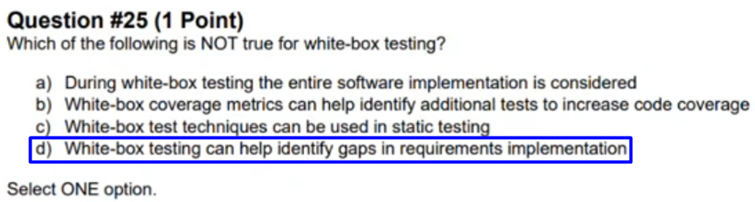

Question 26
FL Review - start at 1:36:54
Q26
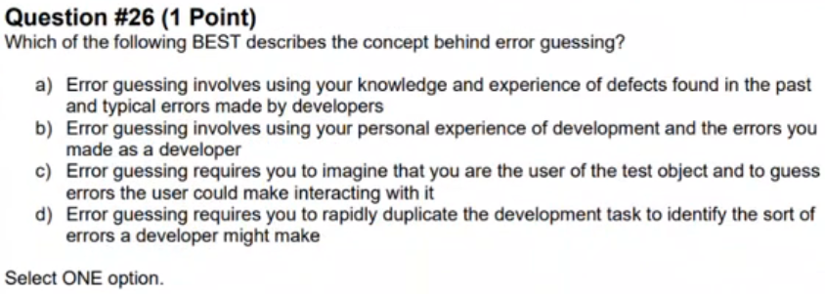
Q26 - Answer
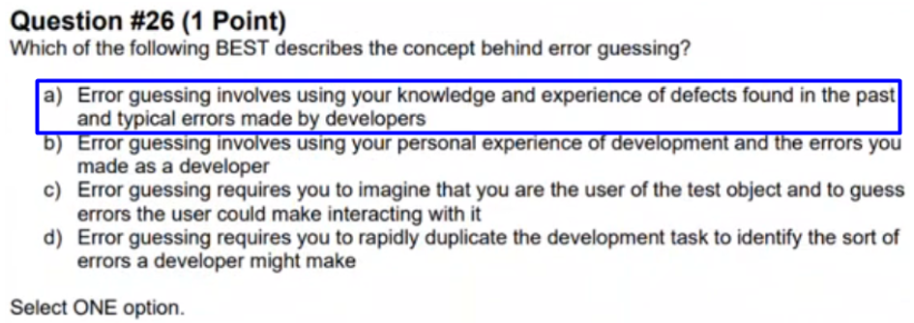

Question 27
FL Review - start at 1:39:49
Q27
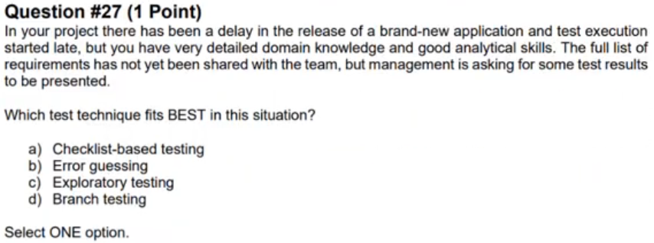
Q27 - Answer
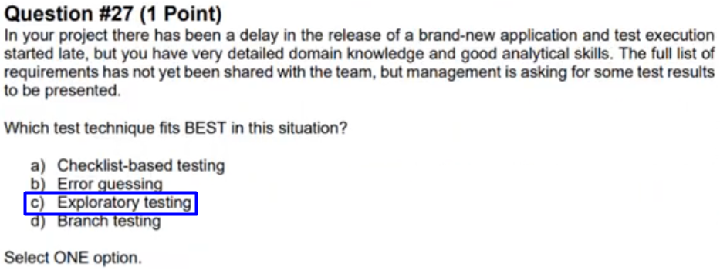

Question 28
FL Review - start at 1:42:17
Q28
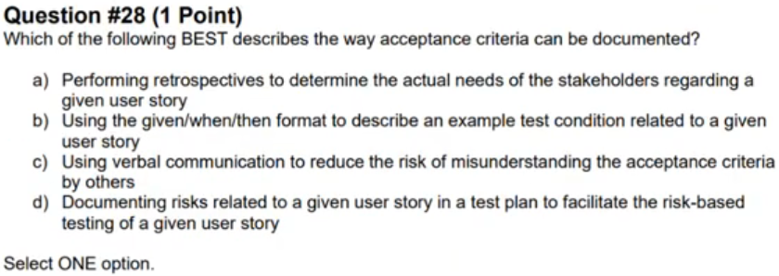
Q28 - Answer
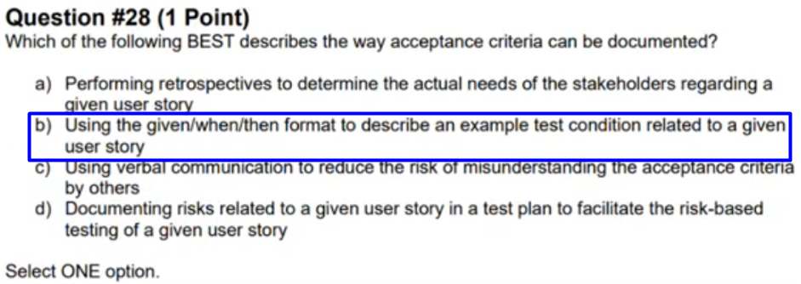

Question 29
FL Review - start at 1:46:40
Q29
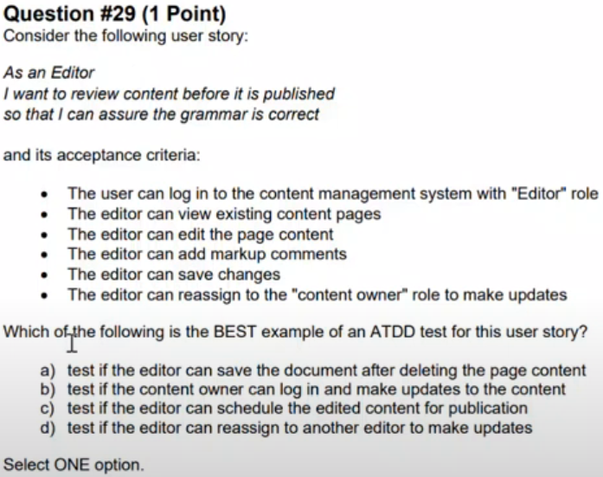
Q29 - Answer
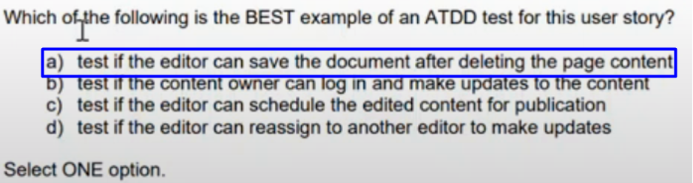

Question 30
FL Review - start at 1:50:37
Q30
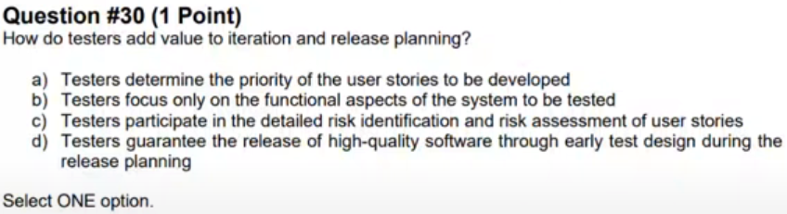
Q30 - Answer
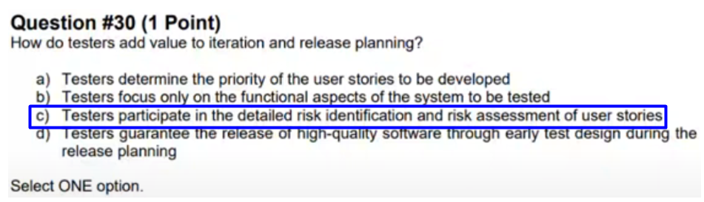

Question 31
FL Review - start at 1:53:44
Q31
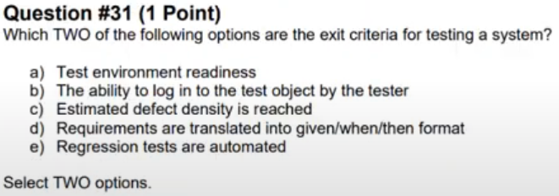

Q31 - Answer
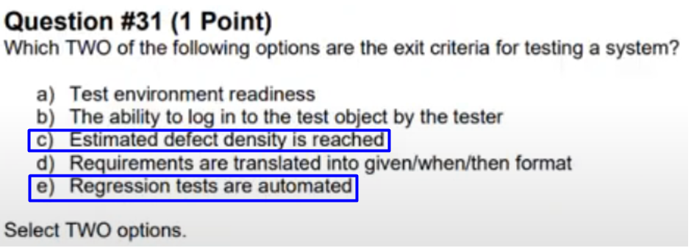

Question 32
FL Review - start at 1:58:18
Q32
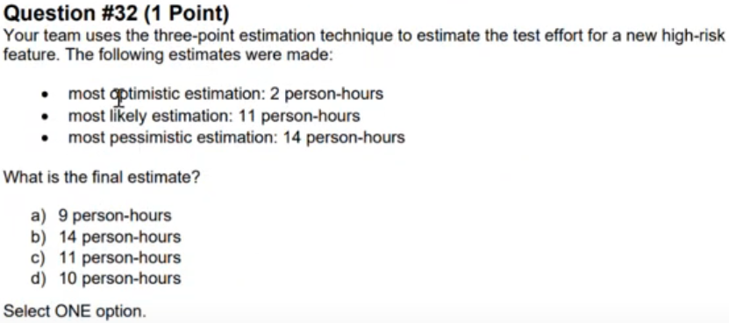

Q32 - Answer
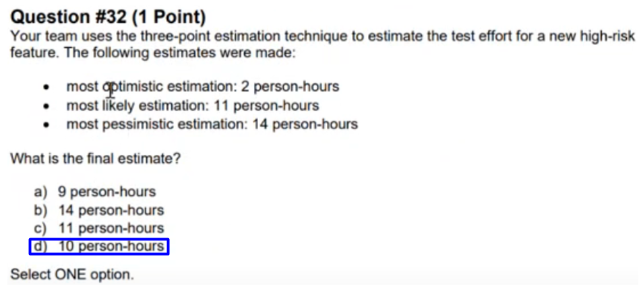

Question 33
FL Review - start at 2:00:05
Q33
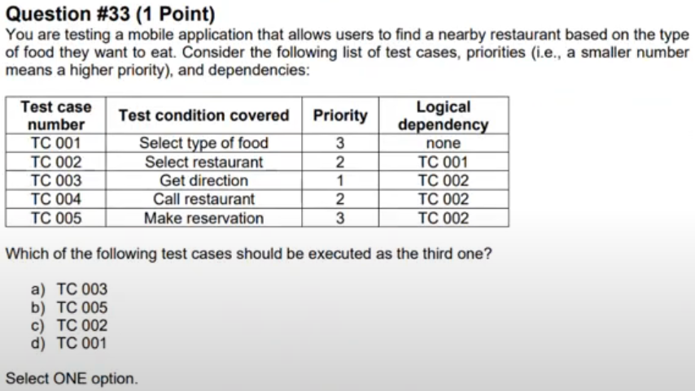

Q33 - Answer
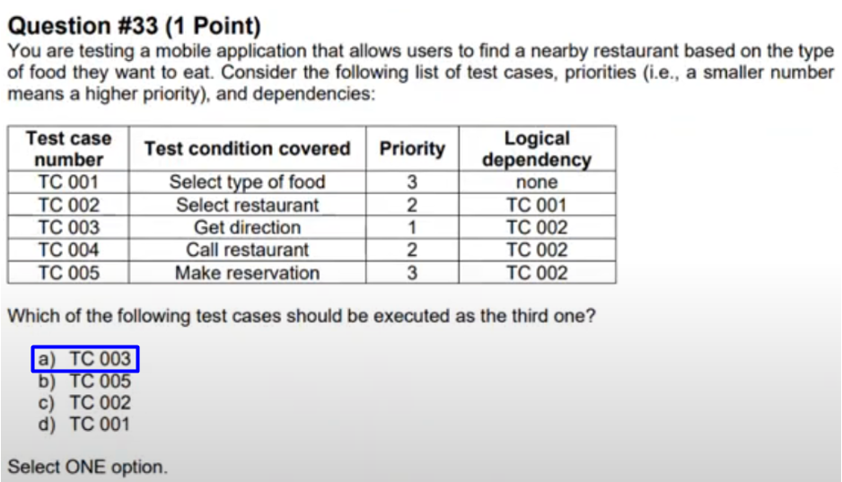

Question 34
FL Review - start at 2:02:50
Q34
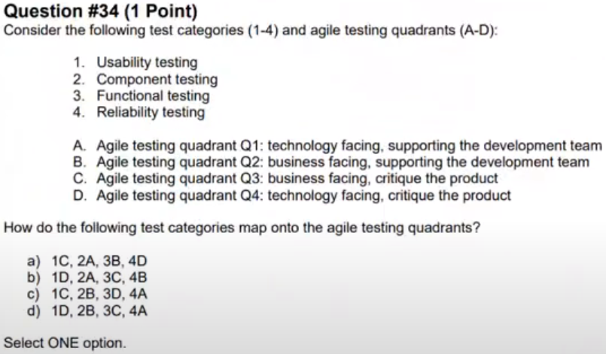
Q34 - Answer
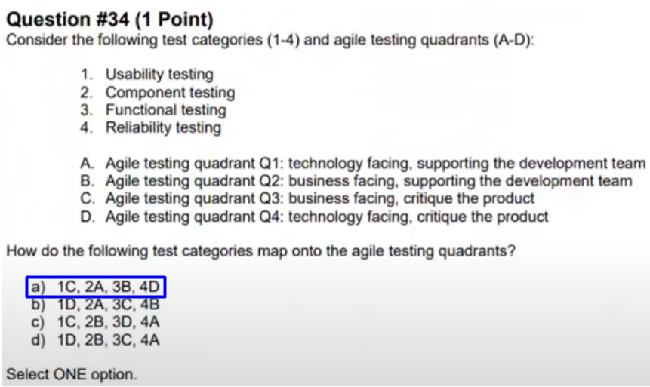

Question 35
FL Review - start at 2:09:03
Q35
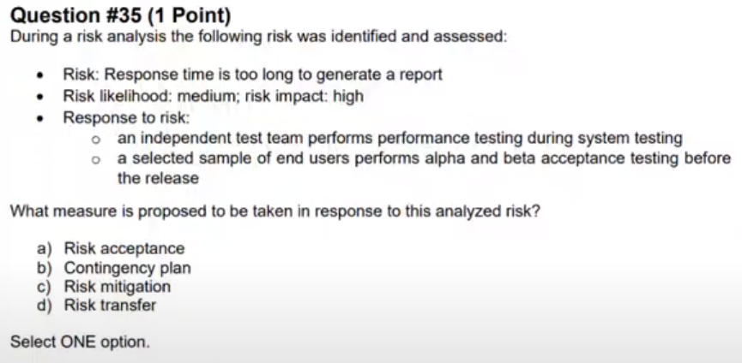
Q35 - Answer
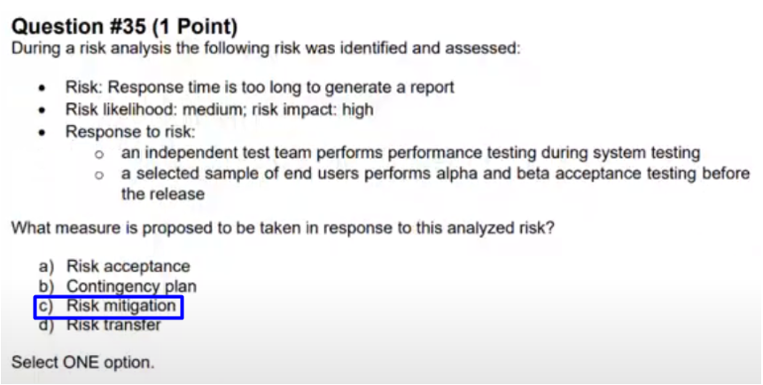

Question 36
FL Review - start at 2:11:00
Q36
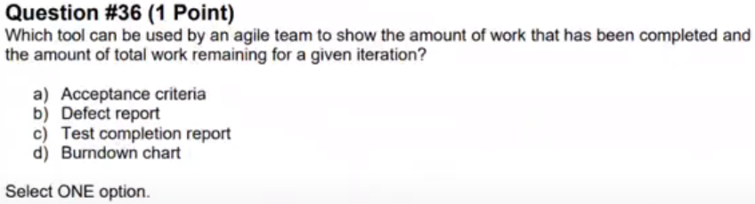
Q36 - Answer
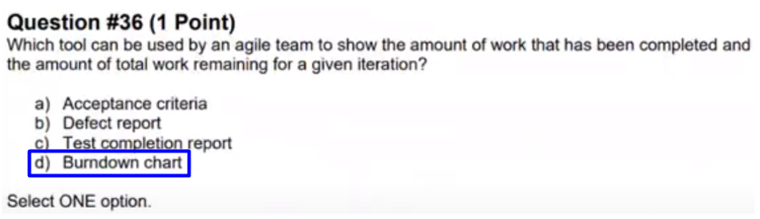

Question 37
FL Review - start at 2:12:08
Q37
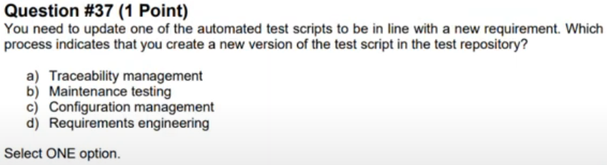
Q37 - Answer
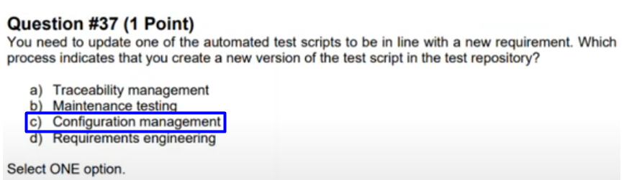

Question 38
FL Review - start at 2:14:13
Q38
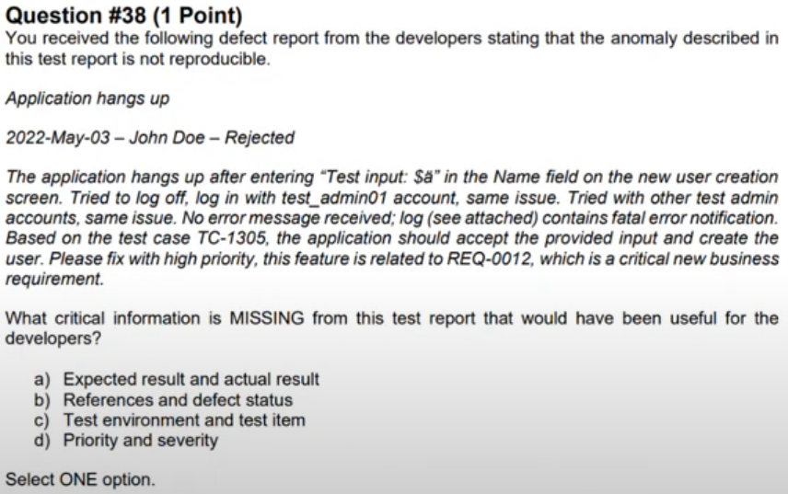
Q38 - Answer
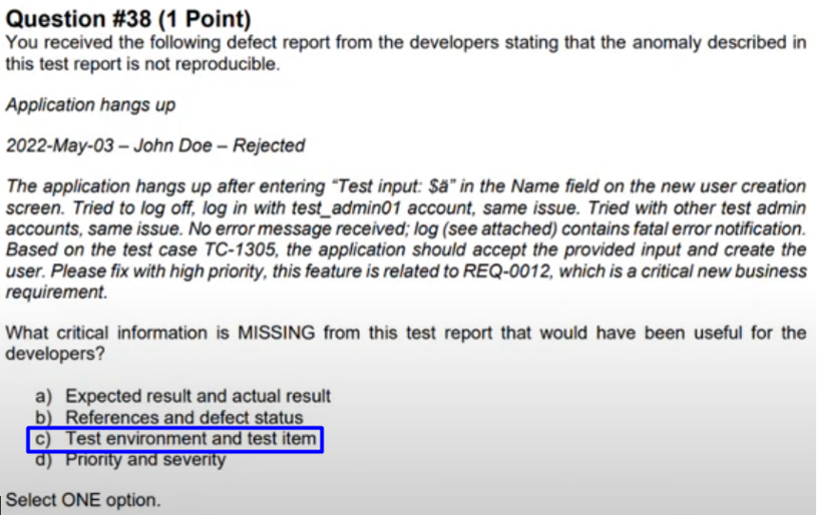

Question 39
FL Review - start at 2:17:26
Q39
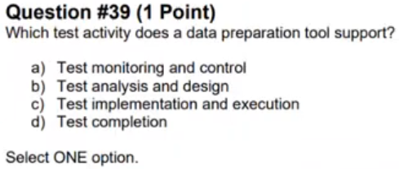
Q39 - Answer
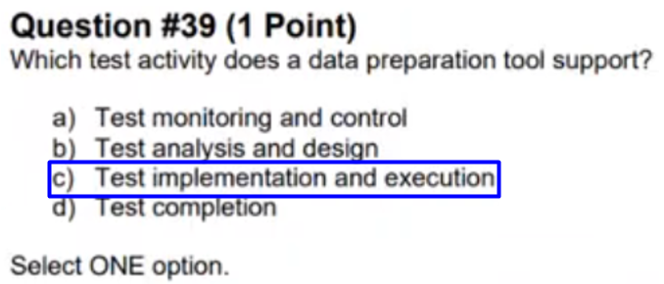

Question 40
FL Review - start at 2:18:21
Q40
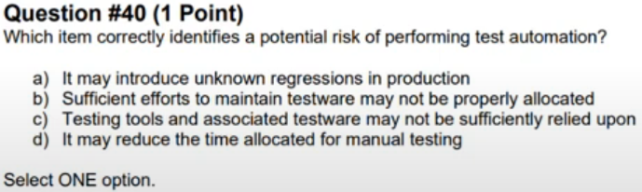
Q40 - Answer
